 | This document is written in Easy Read.  That means it is written so it is easy to understand.
 | We are The Gordon.  We are a TAFE in Victoria Australia.
 | You might not know some words.  These words are in blue the first time we use them.  We explain them after we use them.
 | This document is about our new Centre of Excellence in Disability Inclusion.
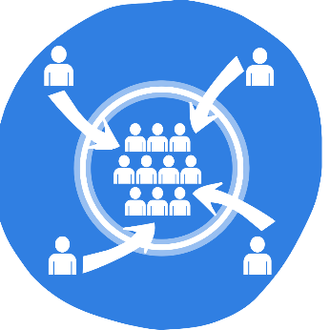 | Inclusion means that everyone:  - is welcome  - is valued  - has what they need to be there.
 | A Centre of Excellence
 | A group of people who work together to work better can be called a centre of excellence.
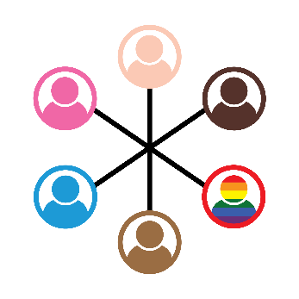 | Our Centre of Excellence will:  - Be a diverse group  Diverse means different.
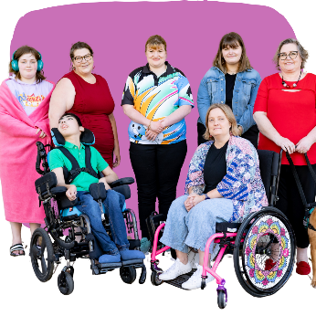 | Diverse people might include people who:  - Have diverse disabilities
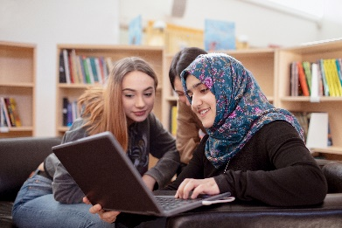 | - Are from different countries  - Speak different languages
 | - Are part of the LGBTQI community  - Are different ages or religions.
 | The Centre of Excellence will work on:  - Ways we can work better  - Sharing what we know  - Finding new ideas.
 | Why The Gordon needs a Centre of Excellence  The Gordon wants to make it easier for more disabled people to study here.
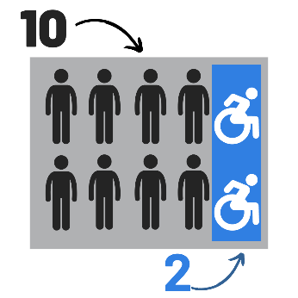 | Key facts  For every 10 people in Victoria:  - 2 people have disabilities
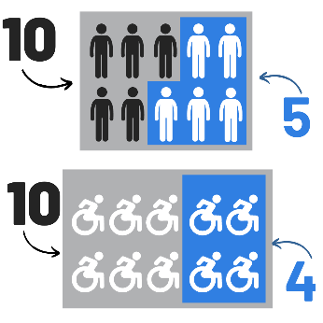 | For every 10 TAFE students in Victoria:  - 5 people without disabilities complete their TAFE studies  - But 4 people with disabilities complete their TAFE studies.
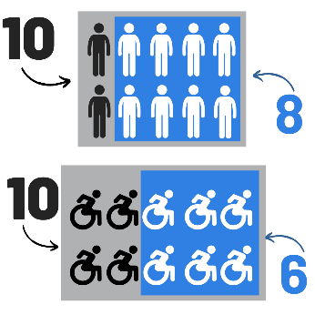 | For every 10 TAFE students in Victoria:  - 8 people without disabilities have a job  - But 6 people with disabilities have a job.
 | What the Centre will do
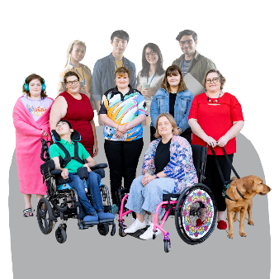 | We will bring people together including:  - learners and graduates with disabilities  - access and inclusion TAFE Networks  - educators  - people working in the disability sector.
We will learn and share good practices for learners with disabilities to:
- access TAFE
- take part in learning
- complete their studies at TAFE.
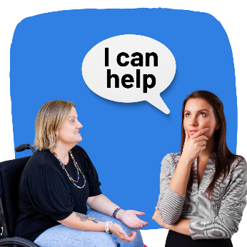 | We will help Victorian TAFEs to learn more about supporting people with disabilities to learn.
 | We will find ways to help TAFE students with disabilities to find work after their studies.
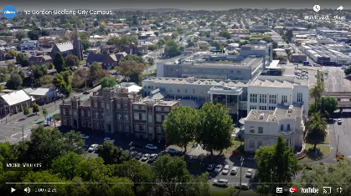 | Work with people with disabilities to:  - See what is not working well for them in The Gordon’s Geelong city campus  - Update the Geelong city campus so it is more inclusive.
 | How we will do this
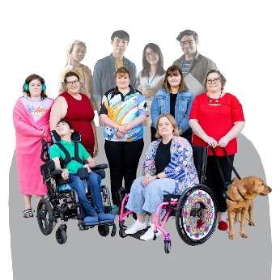 | We will include people with disabilities when we create our vision and model for the Centre of Excellence.
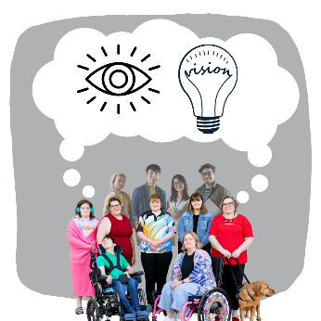 | A vision is a dream for what we want to happen through our work.
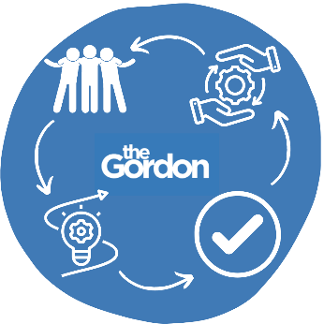 | A model is the way we will set up the Centre of Excellence.  A model also explains how it will do its work.
We will work with diverse people to:
- Find answers to problems we know about
- Design new and better ways of working.
 | To find out more:  - email coeinclusion@gordontafe.edu.au
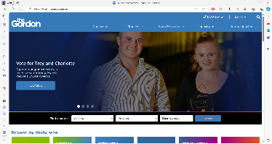 | - or visit https://www.thegordon.edu.au/

Easy Read images by The Easy Read Toolbox or through Creative Commons (Microsoft 365).
Easy Read document written by The Easy Read Toolbox for The Gordon.

