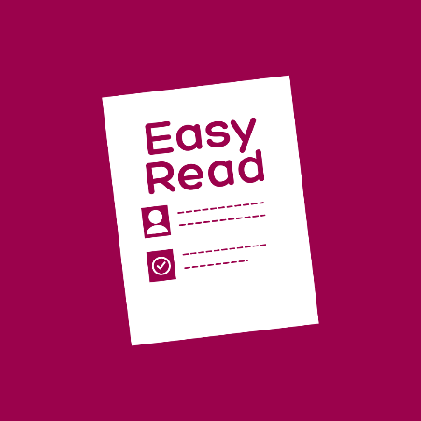 | This document is written in Easy Read.  That means it is written so it is easy to understand.
 | We are The Gordon.  We are a TAFE in Victoria Australia.
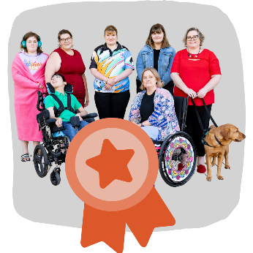 | This document is about a workshop for our new Centre of Excellence in Disability Inclusion
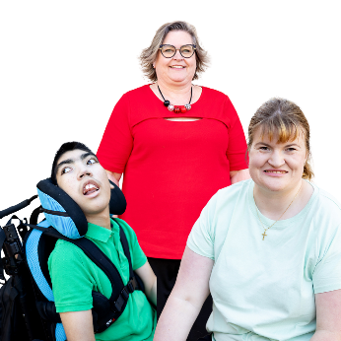 | About the Workshops  Who  We hope that these people will come:  - Learners with disabilities
 | - Others including working in access and inclusion networks, educators, disability sector and workforce training.
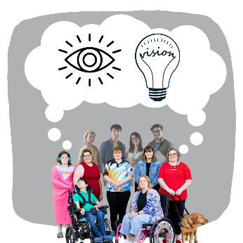 | What  Help us start to create our Vision and Model for our Centre of Excellence.  A vision is a dream for what we want to happen through our work.
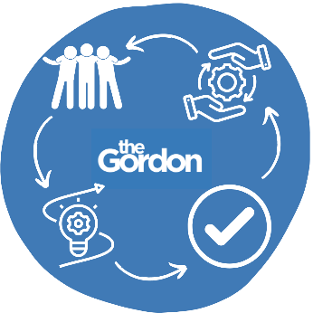 | A model is the way we will set up the Centre of Excellence.  A model also explains how it will do its work.
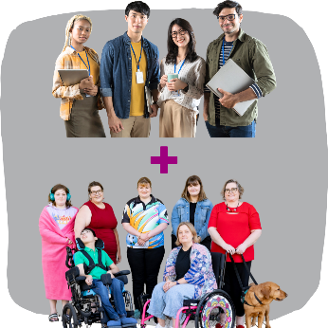 | We want to co-create it with individuals with disabilities and other important people.  Co-creation is when we make it working with the people it is for.
We will talk about:
- What inclusive TAFE looks like
- The changes needed
- What else we need to reach our vision.
 | When  - Governance and Culture Group: Wednesday 26 February, 10am to 2pm  - Capability and Capacity Group: Thursday 27 February, 10am to 2pm  - Student Experience Group: Friday 28 February, 10am to 2pm  - Industry, Pathways and Engagement Group: Tuesday 4 March, 10am to 2pm
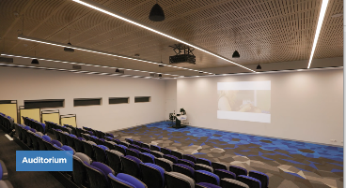 | Where  The Auditorium, The Gordon City Campus, Geelong.

Booking in
You must register or book into a workshop.
Register here:
 | - Email us coeinclusion@gordontafe.edu.au  - or phone us 5225 0518
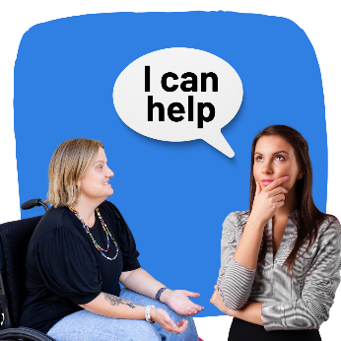 | Tell us your needs to attend  When you register tell us if you need:  - Transport  - Support worker support  - Live captioning  - Auslan  - Or anything else.
 | We will provide some food so tell us if you need special food such as:  - Gluten free  - Dairy free  - Vegan or another alternative.
 | If you cannot come  If you cannot come but would like to talk to us please:  - Call us  - Email us.

Easy Read images by The Easy Read Toolbox or through Creative Commons (Microsoft 365).
Easy Read document written by The Easy Read Toolbox for The Gordon.

